**Table of Contents**

**Introduction…………………………………………………………………….**

* Overview of the Lab**…………………………………………………………………….**
* Objectives of the Tasks**…………………………………………………………………….**

**Task 2: Encryption using Different Ciphers and Modes…………………………………**

* Initial Notes**…………………………………………………………………….**
* Objective**…………………………………………………………………….**

1. AES-128-CBC…………………………………………………………………………………
2. BF-CBC………………………………………………………………………………………….
3. AES-128-CTR……………………………………………………………………………………….

**Analysis and Observations…………………………………………………………………**

* Results and Observations…………………………………………………………………………..
* Key Challenges Faced…………………………………………………………………………….

**Task 3: Encryption Mode – ECB vs. CBC**

* Comparison of Encryption Modes
* Practical Demonstrations

**Task 7: Programming Using the Crypto Library in Java**

* Implementation Details
* Code Examples and Outputs

**Conclusion**

* Summary of the Lab
* Key Learnings and Outcomes

**References**

* SEED Labs Documentation
* Java Crypto Library Resources
* Other Tools and Sources Used

**Introduction**

**Overview of the Lab**

This lab focuses on exploring encryption techniques, specifically secret-key encryption, and understanding their practical applications. By performing hands-on tasks, students will gain insights into how encryption ciphers and modes function, how to avoid common mistakes in cryptography, and how to implement secure encryption programs. The lab also emphasizes the importance of choosing the correct encryption mode to ensure data confidentiality and integrity

**Objectives of the Tasks**

The primary objectives of this lab are as follows:

1. Understand and implement various encryption ciphers and modes, including AES-128-CBC, BF-CBC, and AES-128-CTR.
2. Analyze and compare encryption modes, particularly ECB and CBC, to evaluate their strengths and weaknesses.
3. Develop a Java program using a cryptographic library to encrypt and decrypt data effectively while adhering to best practices.

**Task 2: Encryption using Different Ciphers and Modes**

**Initial Notes**

In this task, we will explore how to use the openssl enc tool to perform encryption and decryption with various ciphers and modes. This involves understanding the command-line options provided by openssl and how encryption parameters, such as keys, initialization vectors (IV), and modes of operation, affect the encryption process. We will also examine the outputs of the encrypted files and compare the results using different ciphers.

**Setup and Preparation**

1. **Environment Setup**:
   * An **Ubuntu Virtual Machine (VM)** with all necessary tools pre-installed, such as openssl.
   * A test text file (plain.txt) was created to serve as the input file for encryption and decryption.
   * The VM was customized according to the lab requirements, including changing the wallpaper and setting up a folder for the lab work.
2. **Understanding openssl enc Command**:
   * The openssl enc command is a versatile tool that supports a variety of ciphers and encryption modes. To get familiar with it, the following manual commands were used:
     + man openssl
     + man enc
   * Key options explored:
     + -e: Specifies encryption mode.
     + -d: Specifies decryption mode.
     + -in <file>: Input file for the operation.
     + -out <file>: Output file where encrypted or decrypted data is stored.
     + -K <key>: The key for encryption or decryption in hexadecimal format.
     + -iv <IV>: The initialization vector for ciphers requiring it.
3. **Test Parameters**:
   * A **16-byte hexadecimal key** (00112233445566778899aabbccddeeff) and a corresponding **16-byte IV** (0102030405060708090a0b0c0d0e0f) were chosen for consistency across ciphers.
   * A baseline encryption file named cipher.bin was used to store encrypted results.
4. **Selection of Ciphers**:
   * Three ciphers were selected for this task:
     + **AES-128-CBC**: A block cipher with Cipher Block Chaining mode.
     + **BF-CBC**: A block cipher using Blowfish algorithm with CBC mode.
     + **AES-128-CTR**: A block cipher with Counter mode for stream-like encryption.
5. **Validation Process**:
   * After encryption, the encrypted file was examined to verify its size and structure.
   * Decryption was performed using the same parameters to ensure the original file could be successfully retrieved.
   * Incorrect keys or IVs were tested to understand failure scenarios.

**Objective**

The objectives of Task 2 are:

1. To implement encryption and decryption processes using openssl and analyze the outputs.
2. To gain a better understanding of the differences between block ciphers (CBC vs. CTR) and how modes of operation affect encryption.
3. To identify potential mistakes (e.g., mismatched keys or IVs) and understand their implications for security and data integrity.

This detailed preparation sets the stage for the practical implementation of Task 2

**AES-128-CBC:**

This mode CBC requires

* 1. plain text
  2. initialization vector
  3. key

to begin encryption

A-create txt file

1-Save plain text file>>>plain.txt 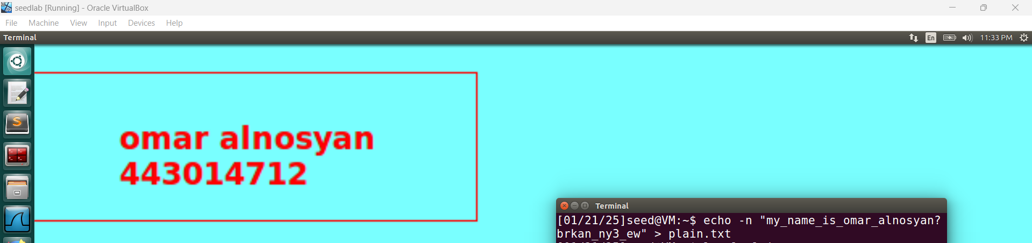

2-print the hex of file using ghex command   
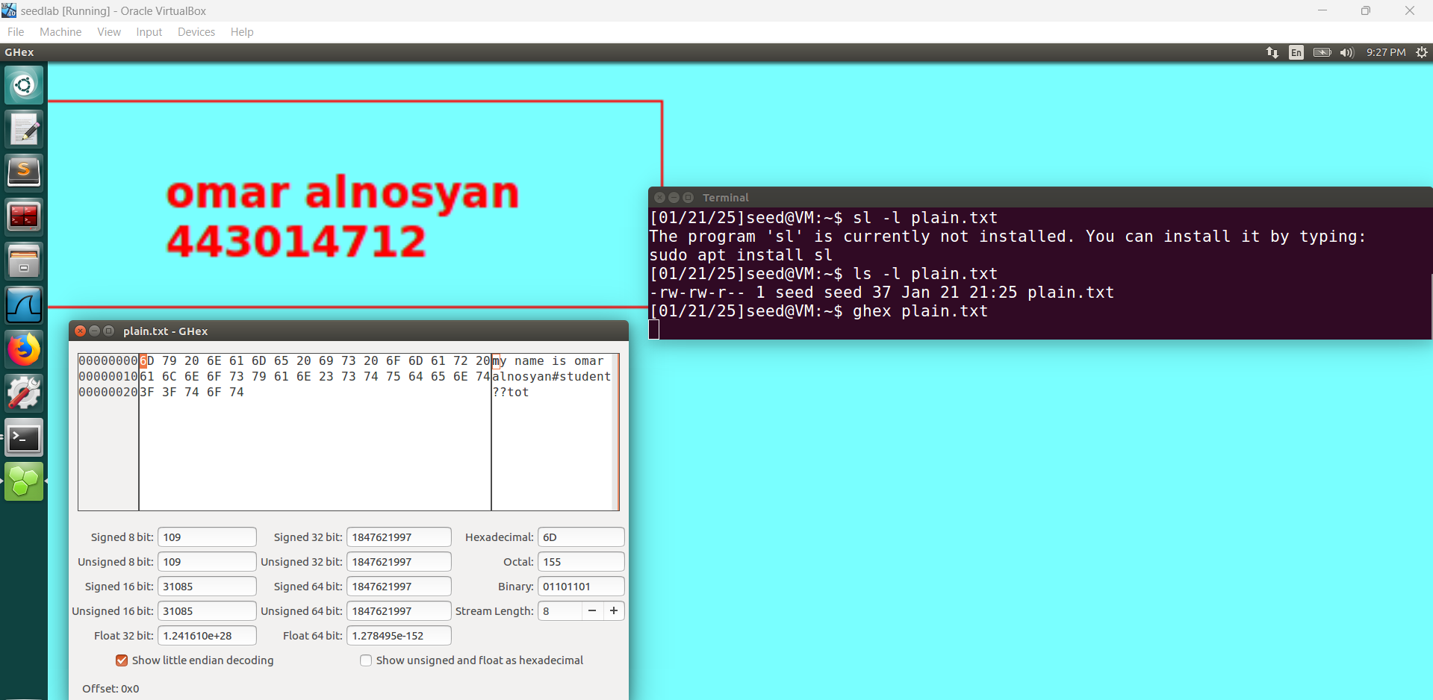

3-print the hex of file using xxd command 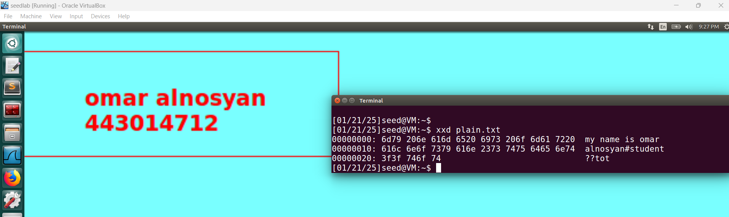

4-print the number of character text 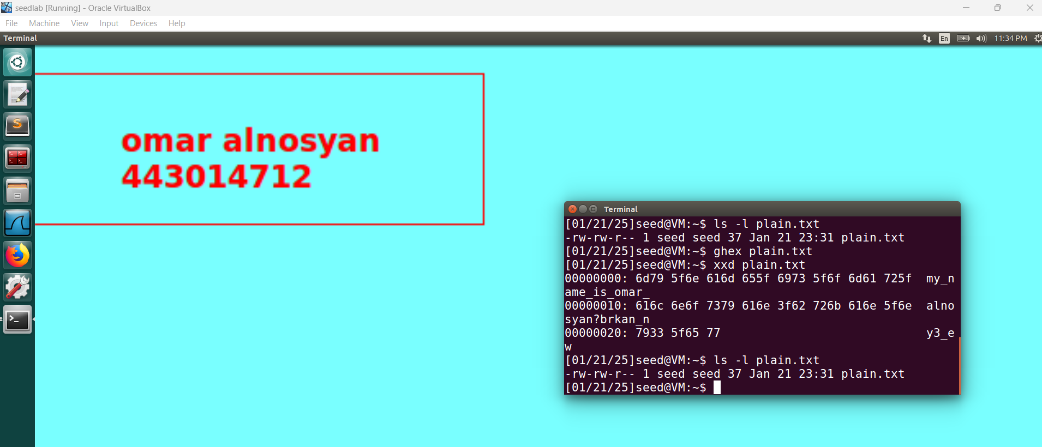

**B)encrypt using AES-128-CBC  
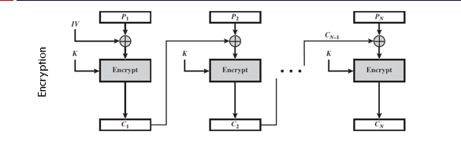**

PLAIN TEXT : my name is omar alnosyan#student??tot  
key:987654321ccbbaa4

IV: 9988776655443322

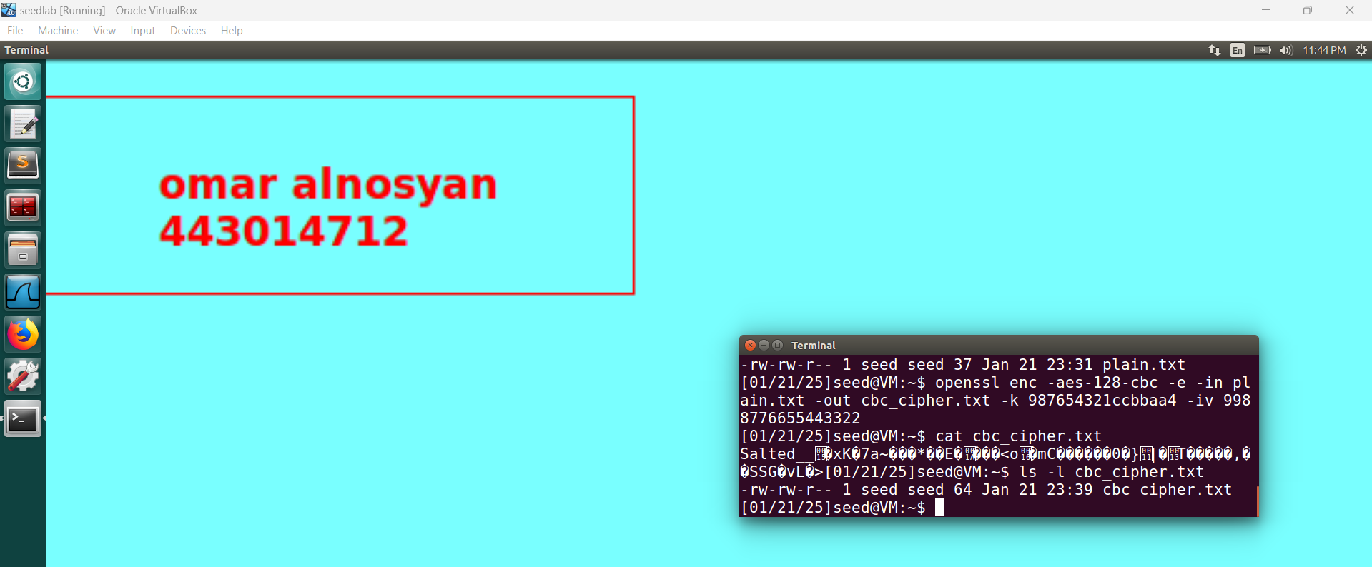

**Ghex cipher.txt** 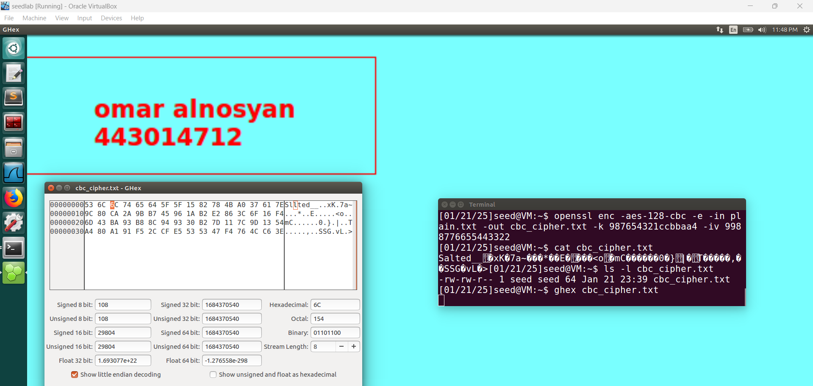

**Observation**

The plain text is encrypted using **AES-128 cipher** in **Cipher Block Chaining (CBC) mode**.

The plain text contains **37 characters** (split as: **16 bytes + 16 bytes + 5 bytes**). Since AES works with fixed block sizes of 16 bytes, padding is added to align the data to the block size. The padded plaintext becomes **48 bytes** (3 blocks of **16 bytes each**):

* **Block 1**: 16 bytes (plaintext).
* **Block 2**: 16 bytes (plaintext).
* **Block 3**: 5 bytes (plaintext) + 11 bytes (padding).

The cipher text contains **64 bytes**, which is calculated as follows:

* **48 bytes** for the encrypted data (16 bytes × 3 blocks).
* **16 bytes** for OpenSSL metadata, including the "Salted__" prefix and an 8-byte salt value.

Thus, the total size of the encrypted file is **64 bytes**

**c)decrypt using AES-128-cbc**

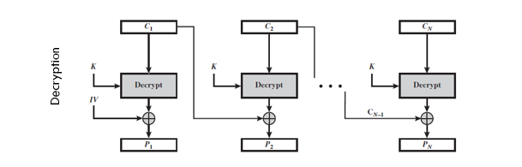

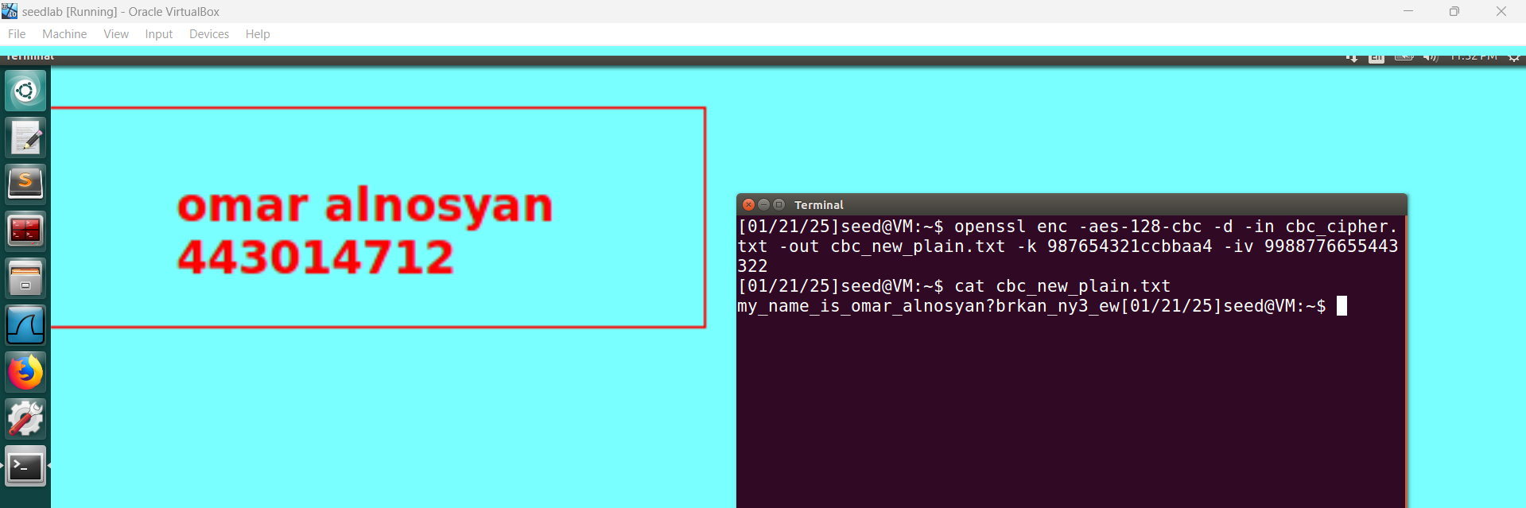

**Print the hex of file using ghex command**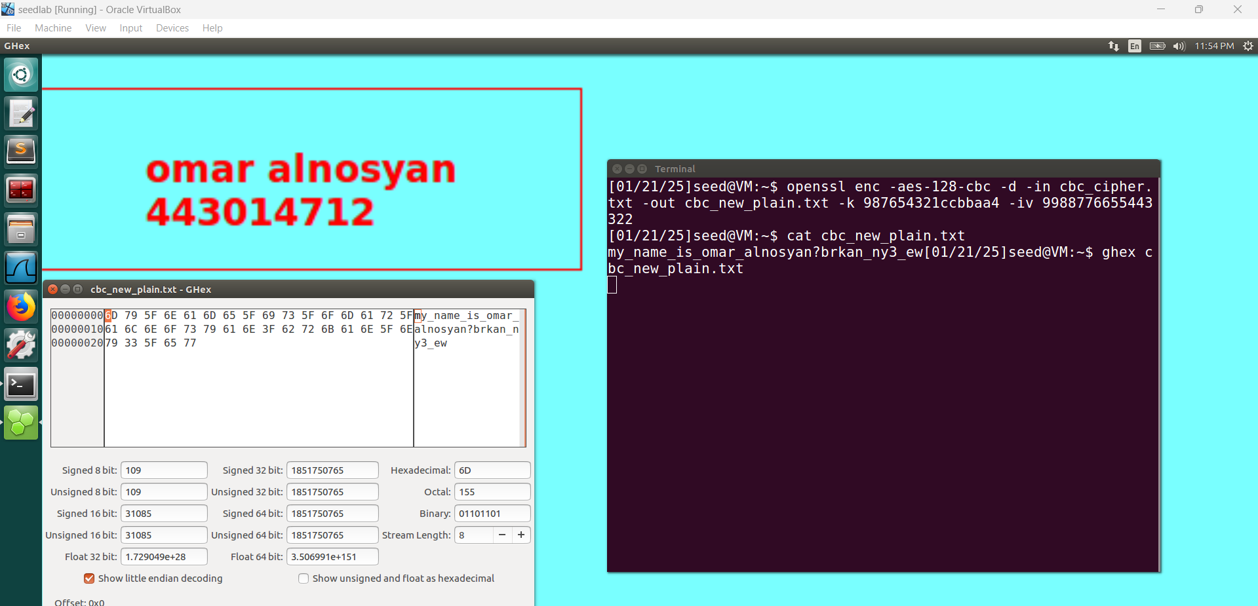

**d)encrypt using AES-128-CFB**

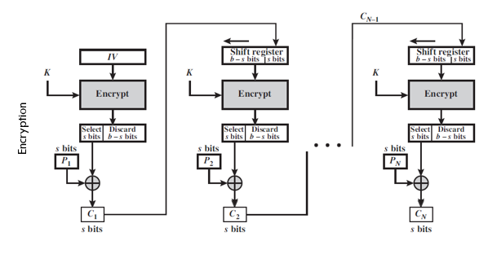

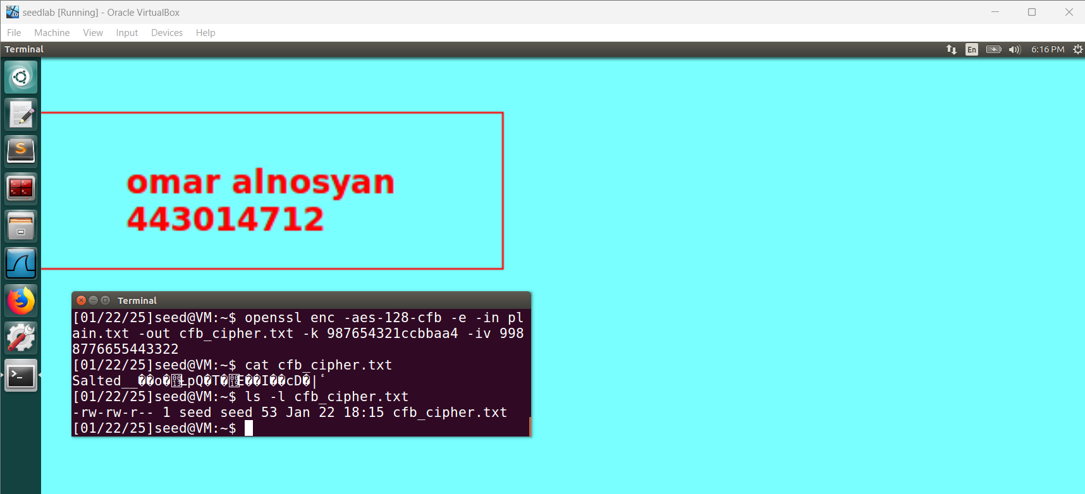

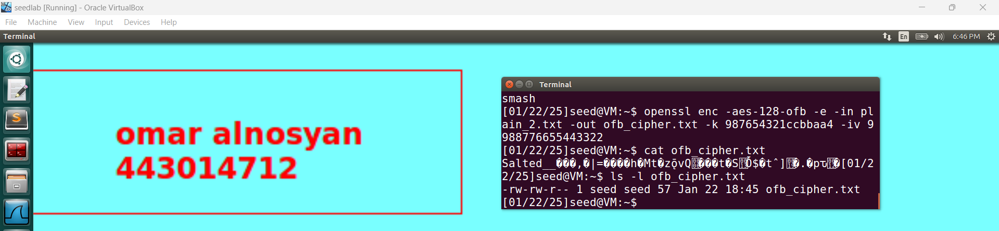

**Print the ghex of cfb_cipher** 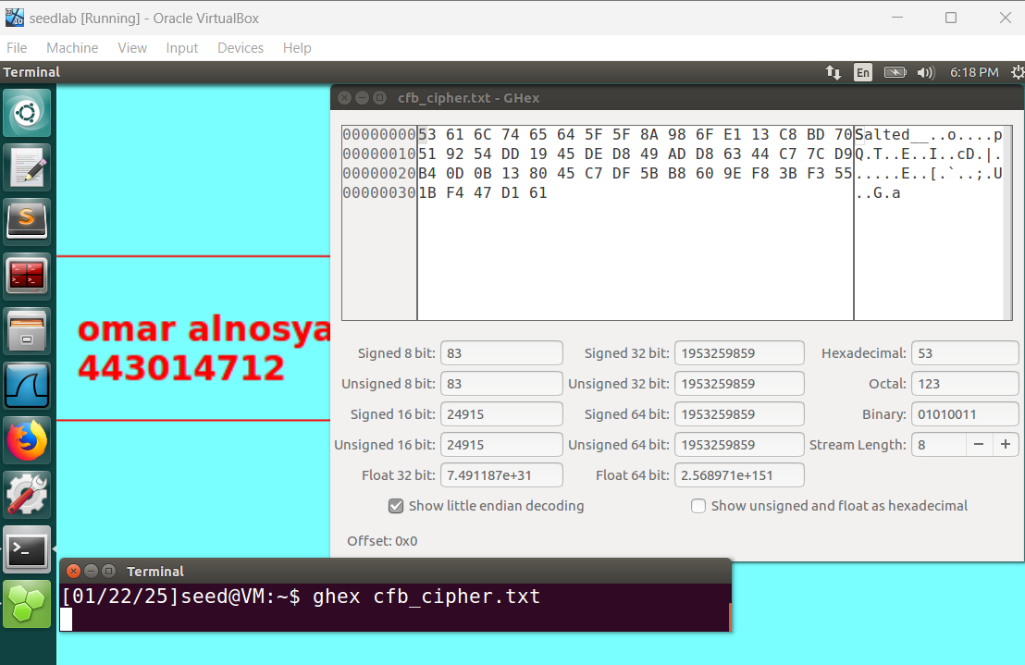

**Observation**

Cipher Feedback (CFB) mode operates like a stream cipher, encrypting plaintext in segments without requiring padding. In this task, a 37-byte plaintext was encrypted using AES-128-CFB with a 16-byte key and IV. The resulting ciphertext size matches the plaintext size (37 bytes), with an additional 16 bytes added by OpenSSL for metadata (Salted__ prefix and salt). This gives a total encrypted file size of 53 bytes.

CFB mode is ideal for streaming data as it processes data in real-time and does not require alignment with block sizes, making it efficient and secure for arbitrary-length data

**E) DECRYPT USING AES-128-CFB**

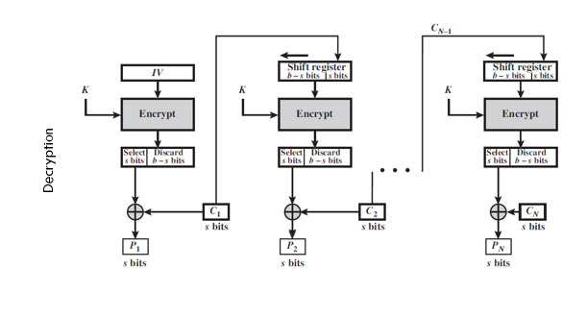

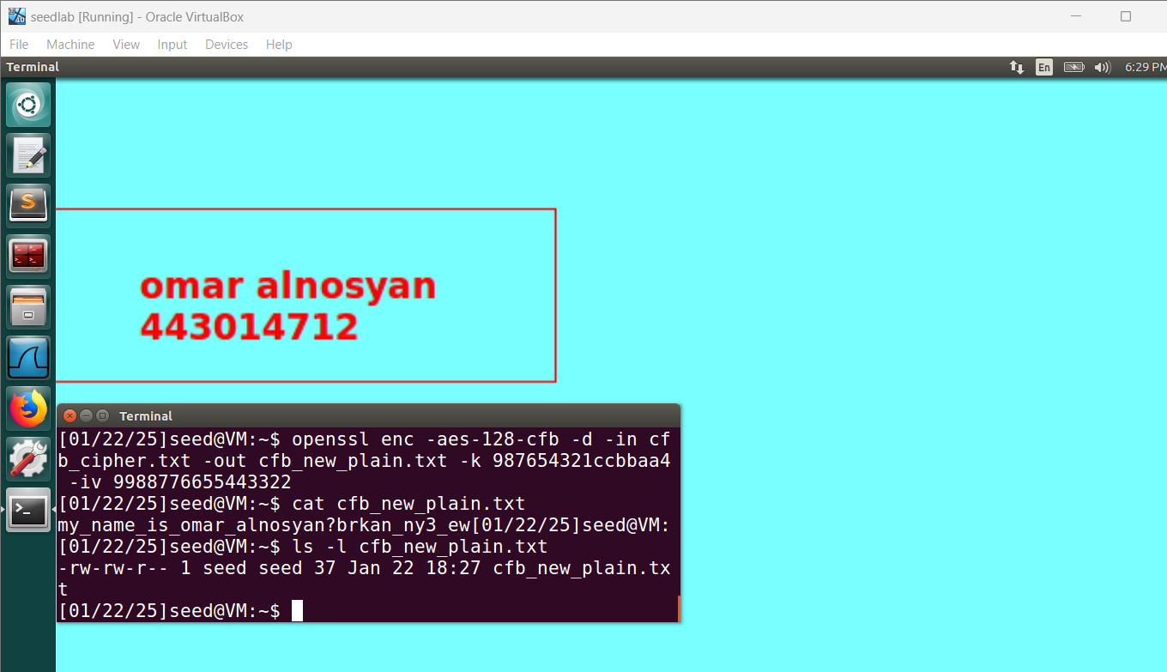

**PRINT THE GHEX OF DECRYPT USING AES-128-CFB**

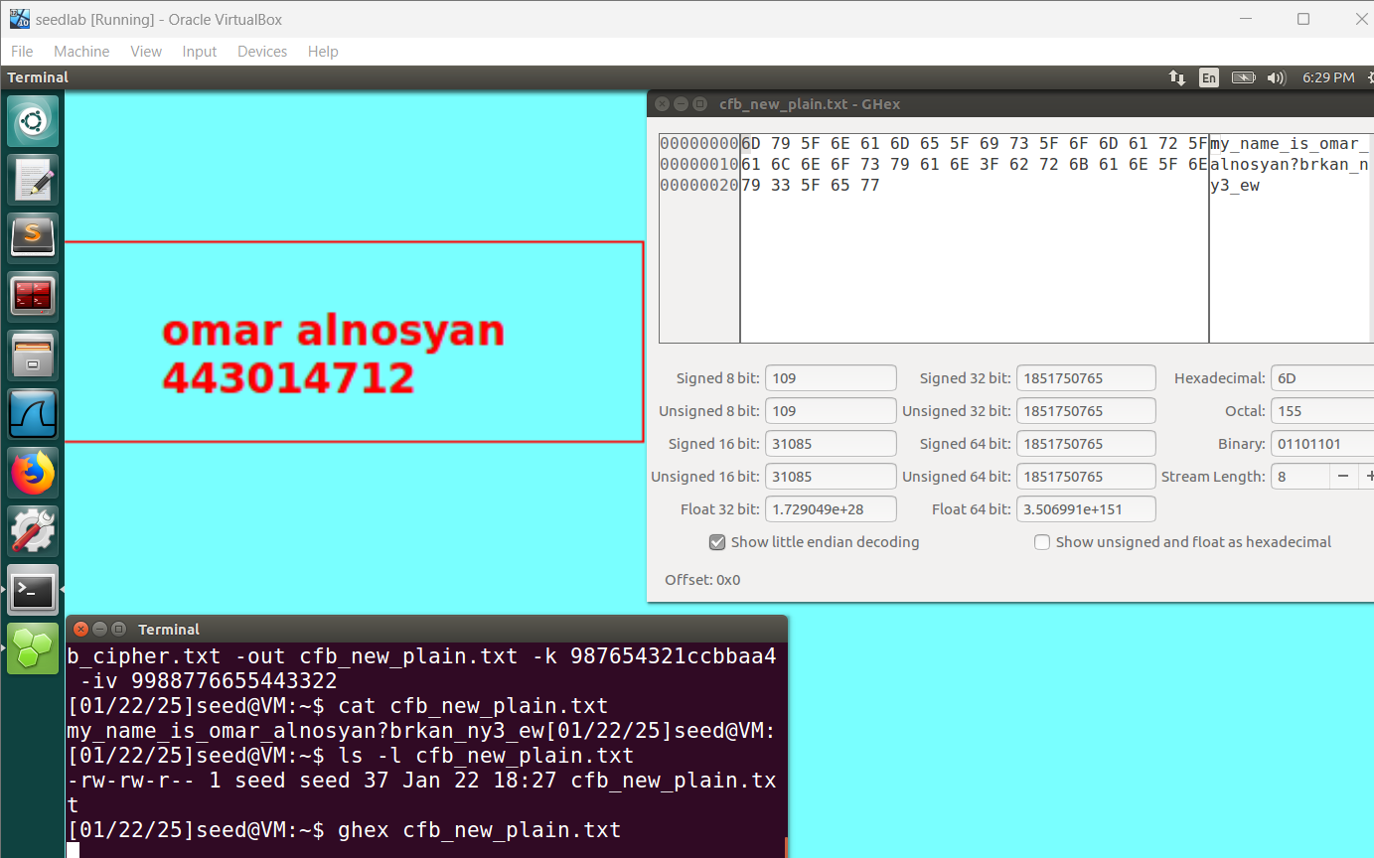

The cipher text is decrypted using AES-128 cipher in Cipher Feedback (CFB) mode. The cipher text contains 37 characters (37 bytes), and the plain text also contains 37 characters (37 bytes)

This shows that the decryption process accurately retains the same length of data, confirming that the original message has been successfully retrieved

F) **Using AES-128-OFB:**

This mode requires

1-an initialization vector

2- key to begin encryption.

OFB mode supports parallel encryption to form cipher text

**Create Text file:**

* Save Plain text to plain_2.txt

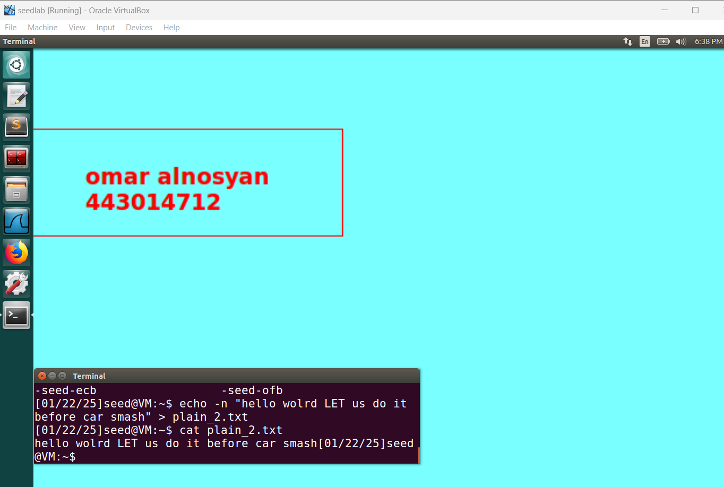

PRINT THE GHEX 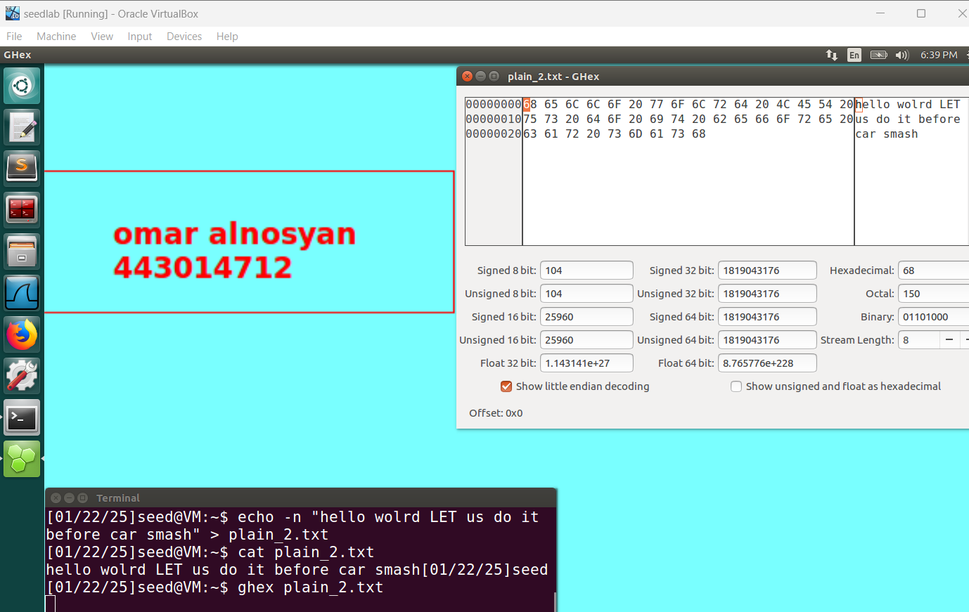

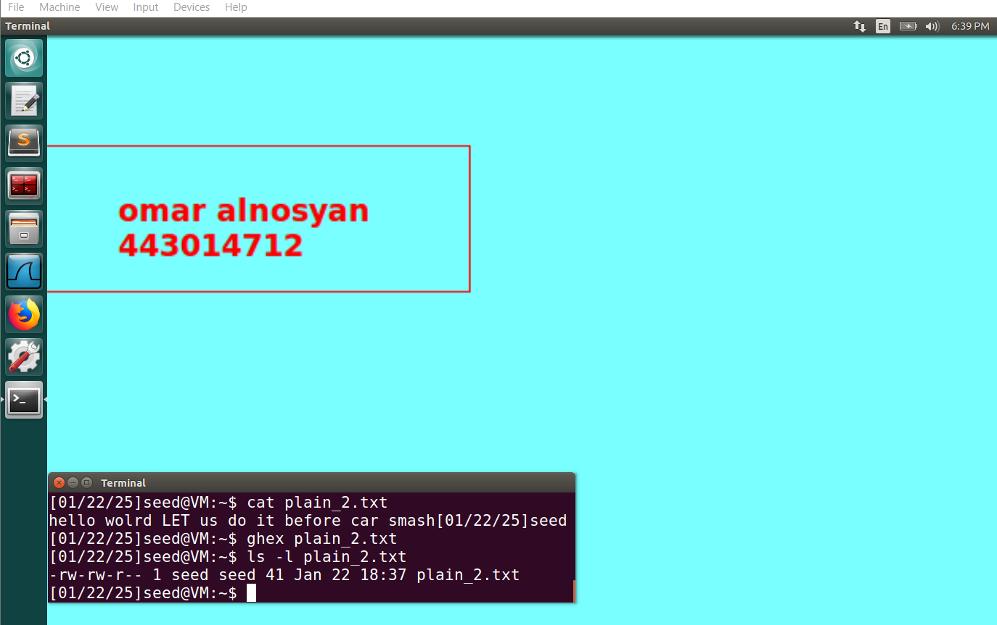

Print the xxd 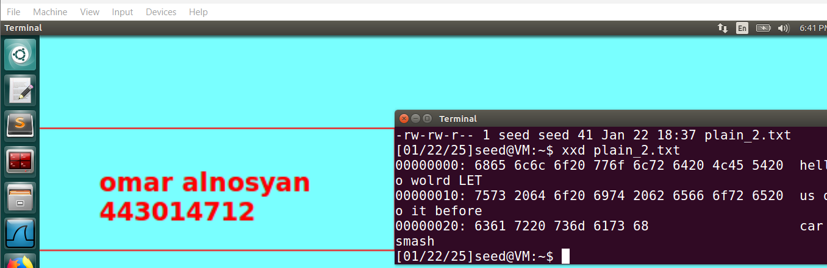

Size of text =41

1-encrypt using aes-128-ofb:

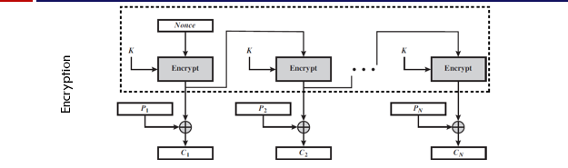

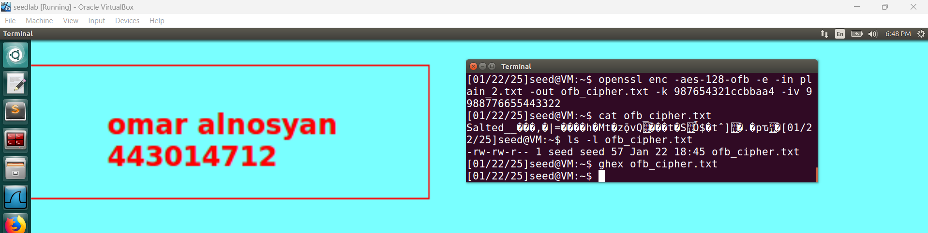

Print the ghex for ofb

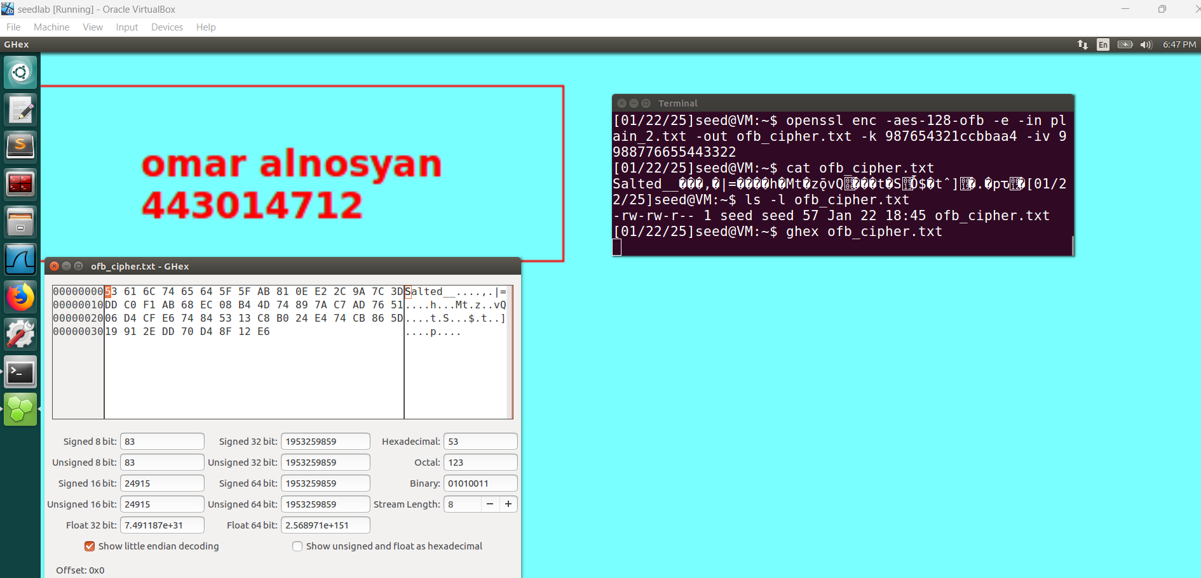

**Observation**The unencrypted text is secured through the AES-128 cipher operating in Output Feedback (OFB) mode.   
  
Given that the plain text consists of 57 characters (57 bytes), the resulting cipher text will also have 57 characters (57 bytes). This equivalence arises from the nature of OFB as a stream cipher, where the plain text is combined with the cipher block using the XOR operation to generate the cipher text

**2-decrypt using aes-128-cfb**

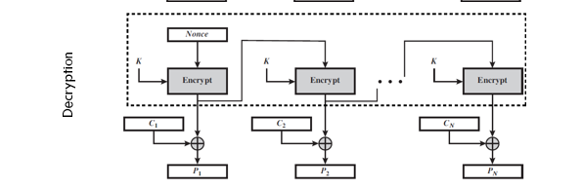

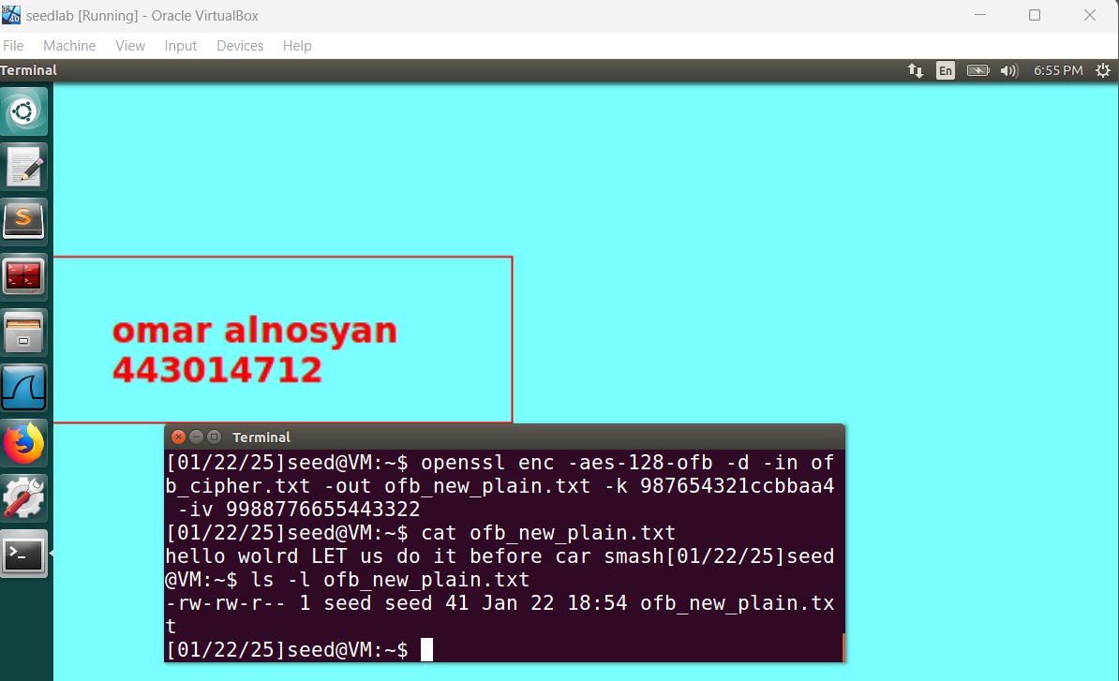

Print using ghex command 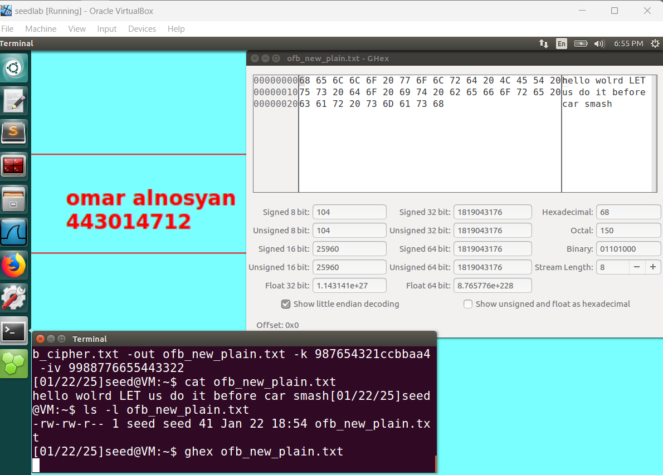

The aad is decrypting the text block using openbber (ofb) mode operating feedback on the aes-128 cipher , The abrasion of the pep most texted , return the header file as 41 characters substring as well.

**Analysis and Observations**

Methods of Block vs Stream: cbc appends padding to section to 16 bytes, on the other side cfb/ ofb are set to make the divided segment smaller.

Ciphertext Size: OpenSSL is lame which adds a addition (adding a salted plus the “Salted__” headder), makes the ciphertext bigger than the plain sentence block.

Key and IV Requirements: AES-128, is very picky, in terms of having a precisely 16 byte key and 16 byte iv. if the key does not match, then the system throws an error.

Improvements: Even so, cbc is good at handling large chunk of data. CFB/OFB, countries similar to more stream oriented ciphers, do not care about the users data size.

Verification: Verify the obtained ciphertext and the plaintext, compare the obtained and expected sizes using xxd or ghex. This will show which mode had a problem with the alignment issue.

**Key Challenges**

* **Command Usage:** Remembering the correct openssl enc flags (e.g., -aes-128-cbc vs. -aes-128-cfb) can be tricky.
* **Key/IV Length:** Providing incorrect sizes (not 16 bytes each) causes encryption/decryption failures.
* **Padding Confusion:** Differentiating between block modes requiring padding (CBC) and stream-like modes (CFB/OFB) can be challenging for beginners.

**Task 3 will examine Encryption Mode - ECB versus CBC.**

Acquire ‘pic_original.bmp‘ which is very straightforward. Apply the desired encryption such that the image is only viewable to people possessing the key and use ECB and CBC modes to perform the encryption.

**Cipher Block Chaining (CBC)**

Print the hex of the original image using the ghex command.

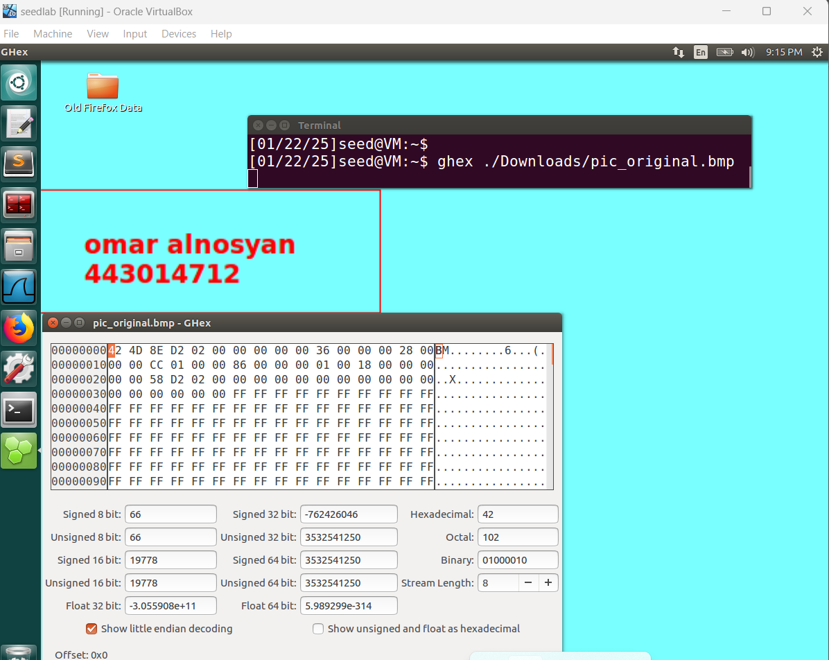

The (54-byte) header value in hex is(1st3row in2nd)box) and payload part of the original bmp file

View the image using eog image viewer 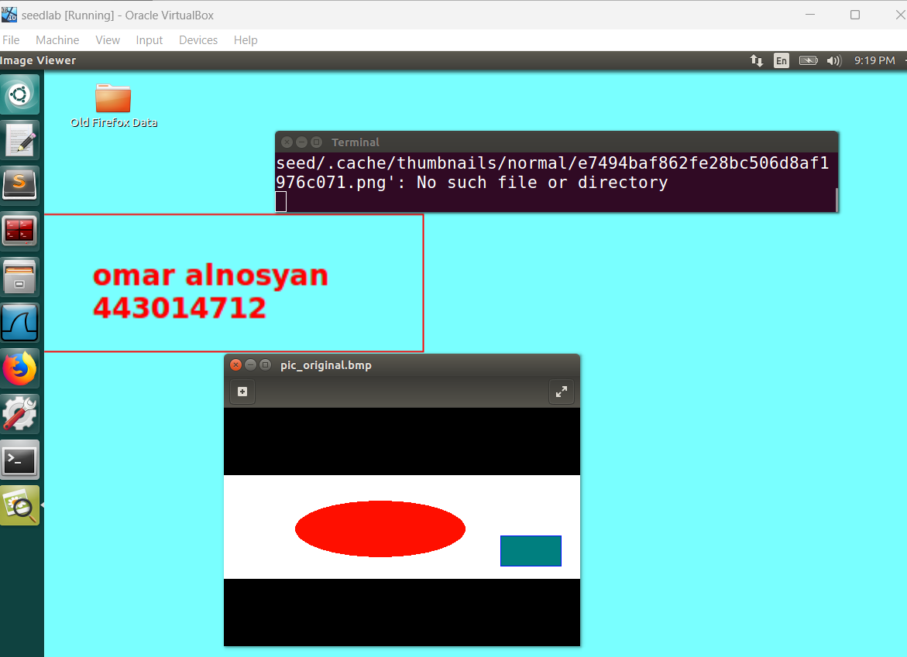

**A) Encrypting the Original Image with AES-128-CBC**  
AES-128-CBC is a block cipher mode where each plaintext block is first XORed with the previous ciphertext block, then encrypted. Consequently, each ciphertext block depends on all previously processed plaintext blocks, chaining them together for added security

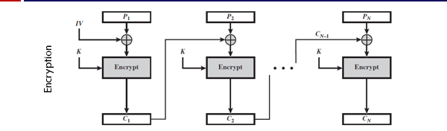

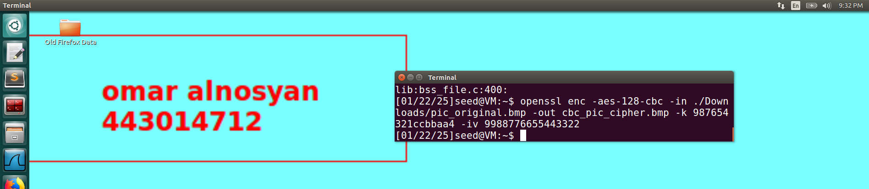

1-add original header to encrypted image

2-view the image using eog image viewer

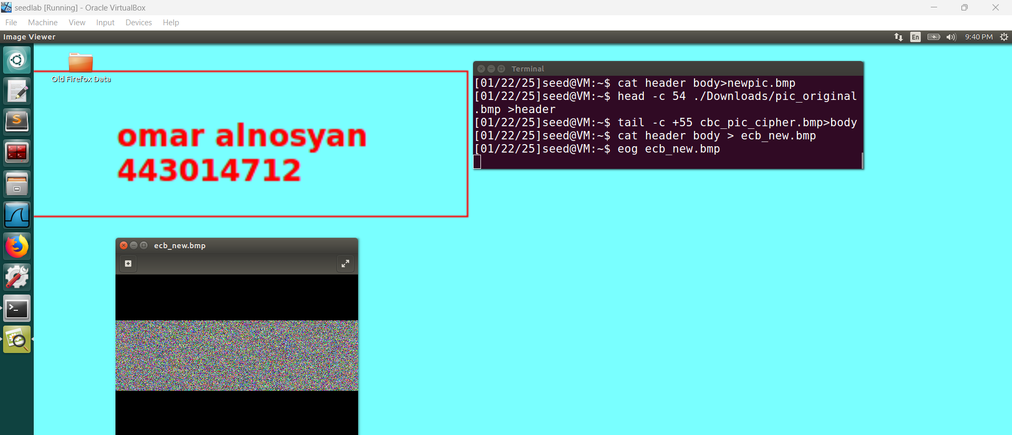

Print the ghex

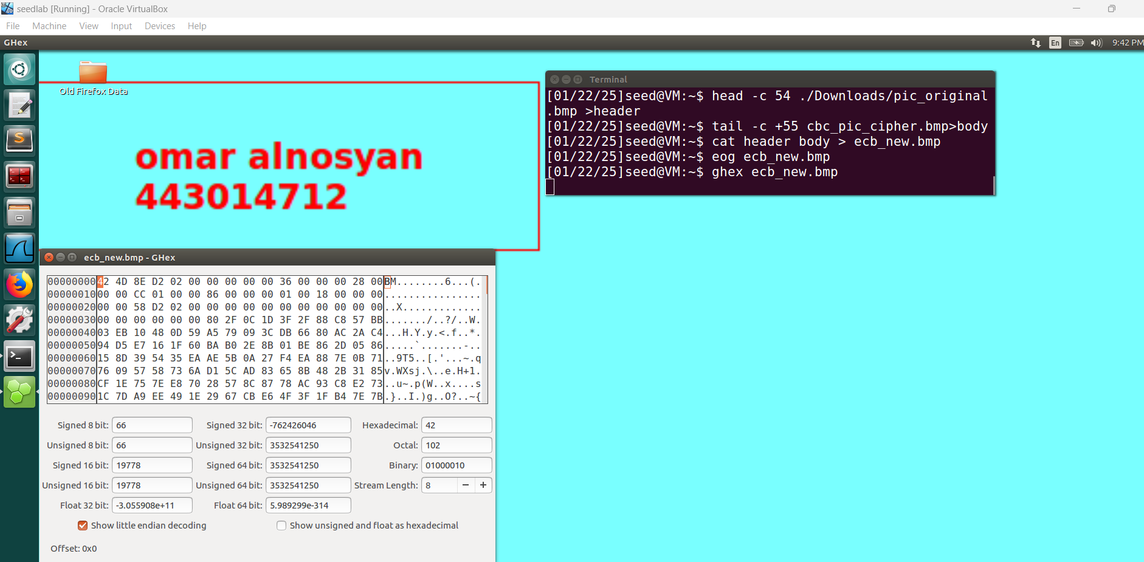

**Observation:**

To make the encrypted BMP recognizable by an image viewer, we replaced its first 54 bytes with the header from the original BMP. This allows the file to open as a valid image, but any recognizable details of the original picture remain hidden. In CBC mode, repeated plaintext blocks do not produce identical ciphertext blocks, so the resulting encrypted image reveals no meaningful information about the original content

**A) Encrypt the original image using AES-128-ECB:**

Electronic Code Book

a simplest block cipher encryption in which a block of plain text is converted into cipher text by encrypting it with a key. No need for IV. 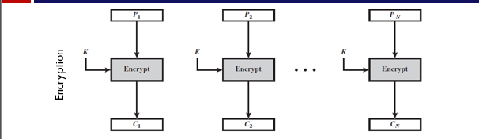

We used **ghex** to view the binary data of the image file, then encrypted the same image using **AES-128-ECB** mode. Since ECB requires no initialization vector, each 16-byte block is directly encrypted with the key, resulting in a straightforward (though less secure) block cipher operation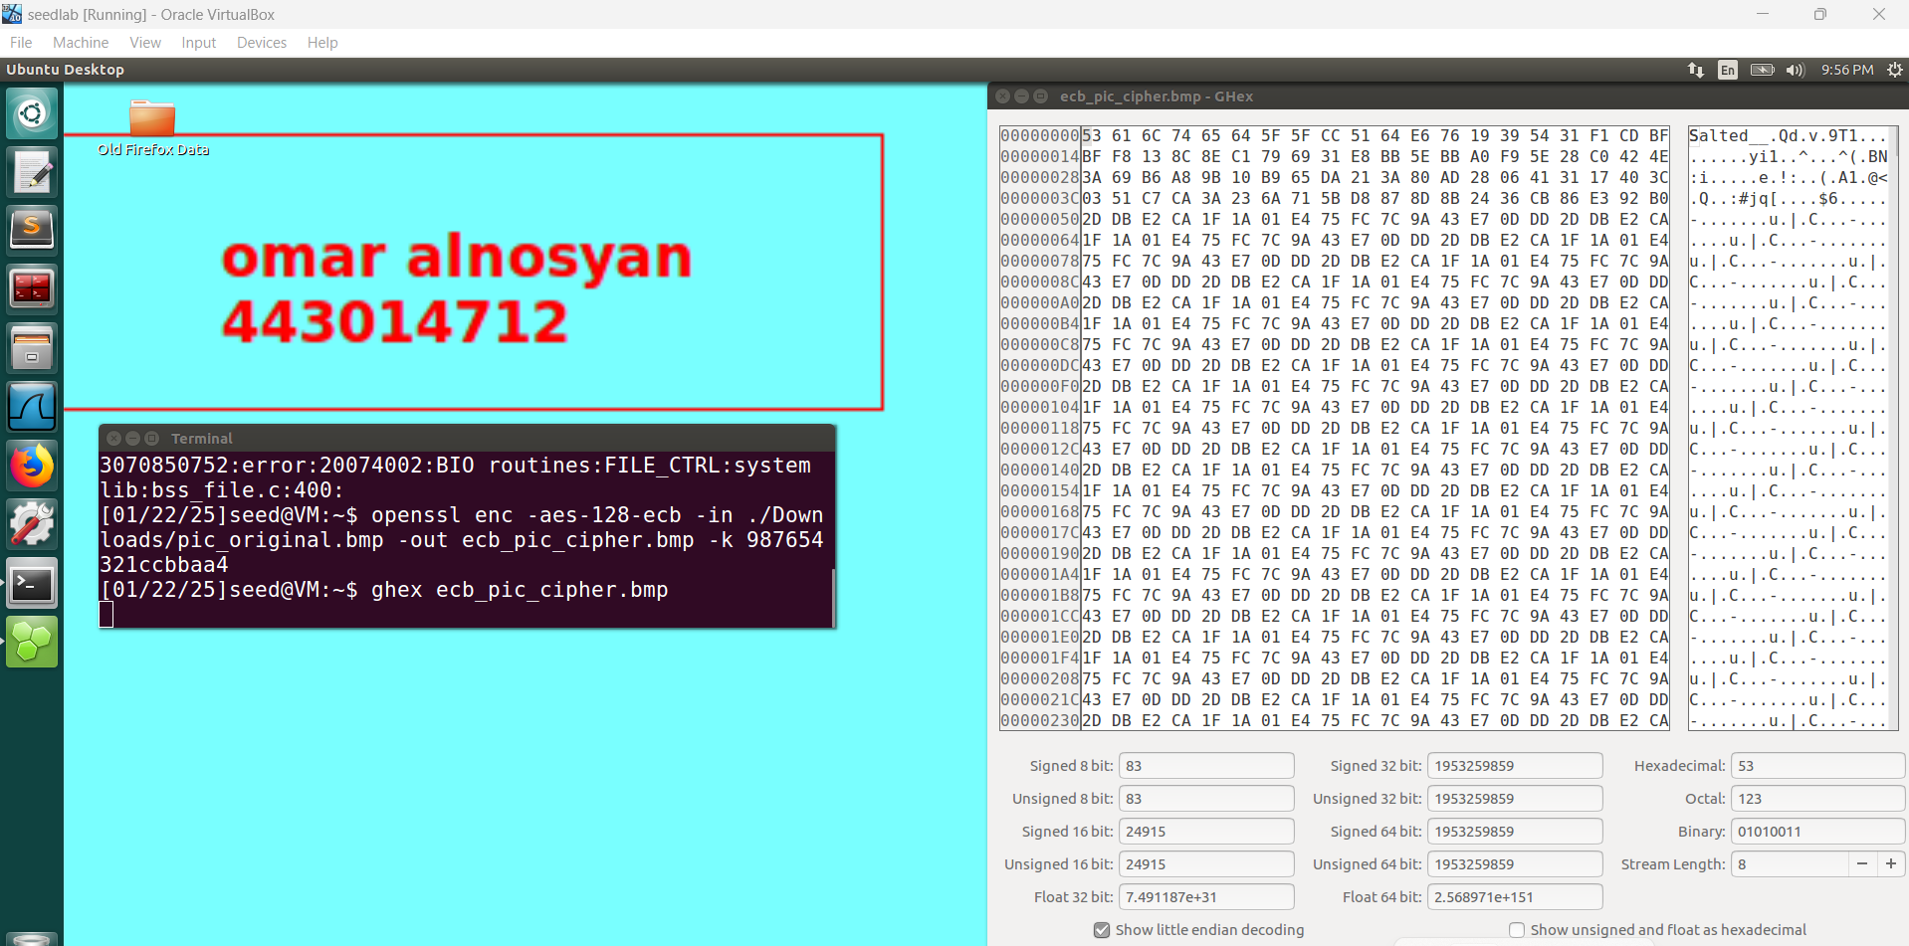

1-add original header to encrypted image

-2view the image using eog image viewr

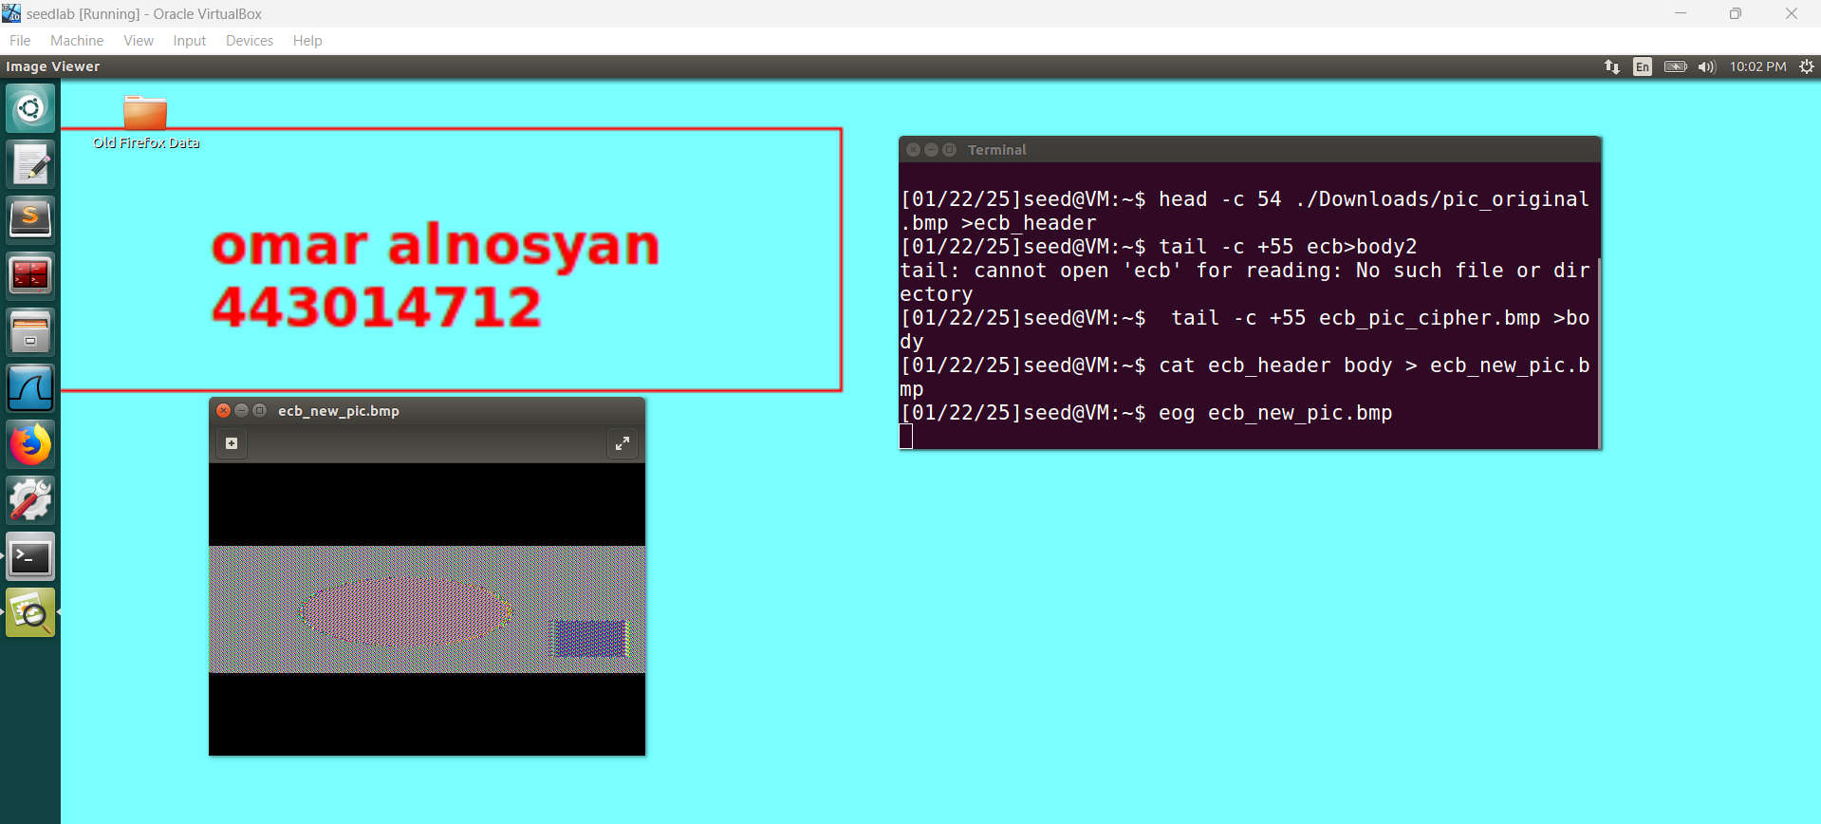

**Observation:**

By replacing the first 54 bytes (the BMP header) of the encrypted file with those from the original BMP, the file can still be opened in an image viewer. However, because AES‐ECB encrypts identical plaintext blocks into identical ciphertext blocks, much of the original image remains discernible in the encrypted version. Although the final image differs from the original, it still reveals much of the original image’s content

**image from own download and cipher it using cbc MODE**

**2- WE SHOW THE IMAGE BY USING EOG COMMAND**

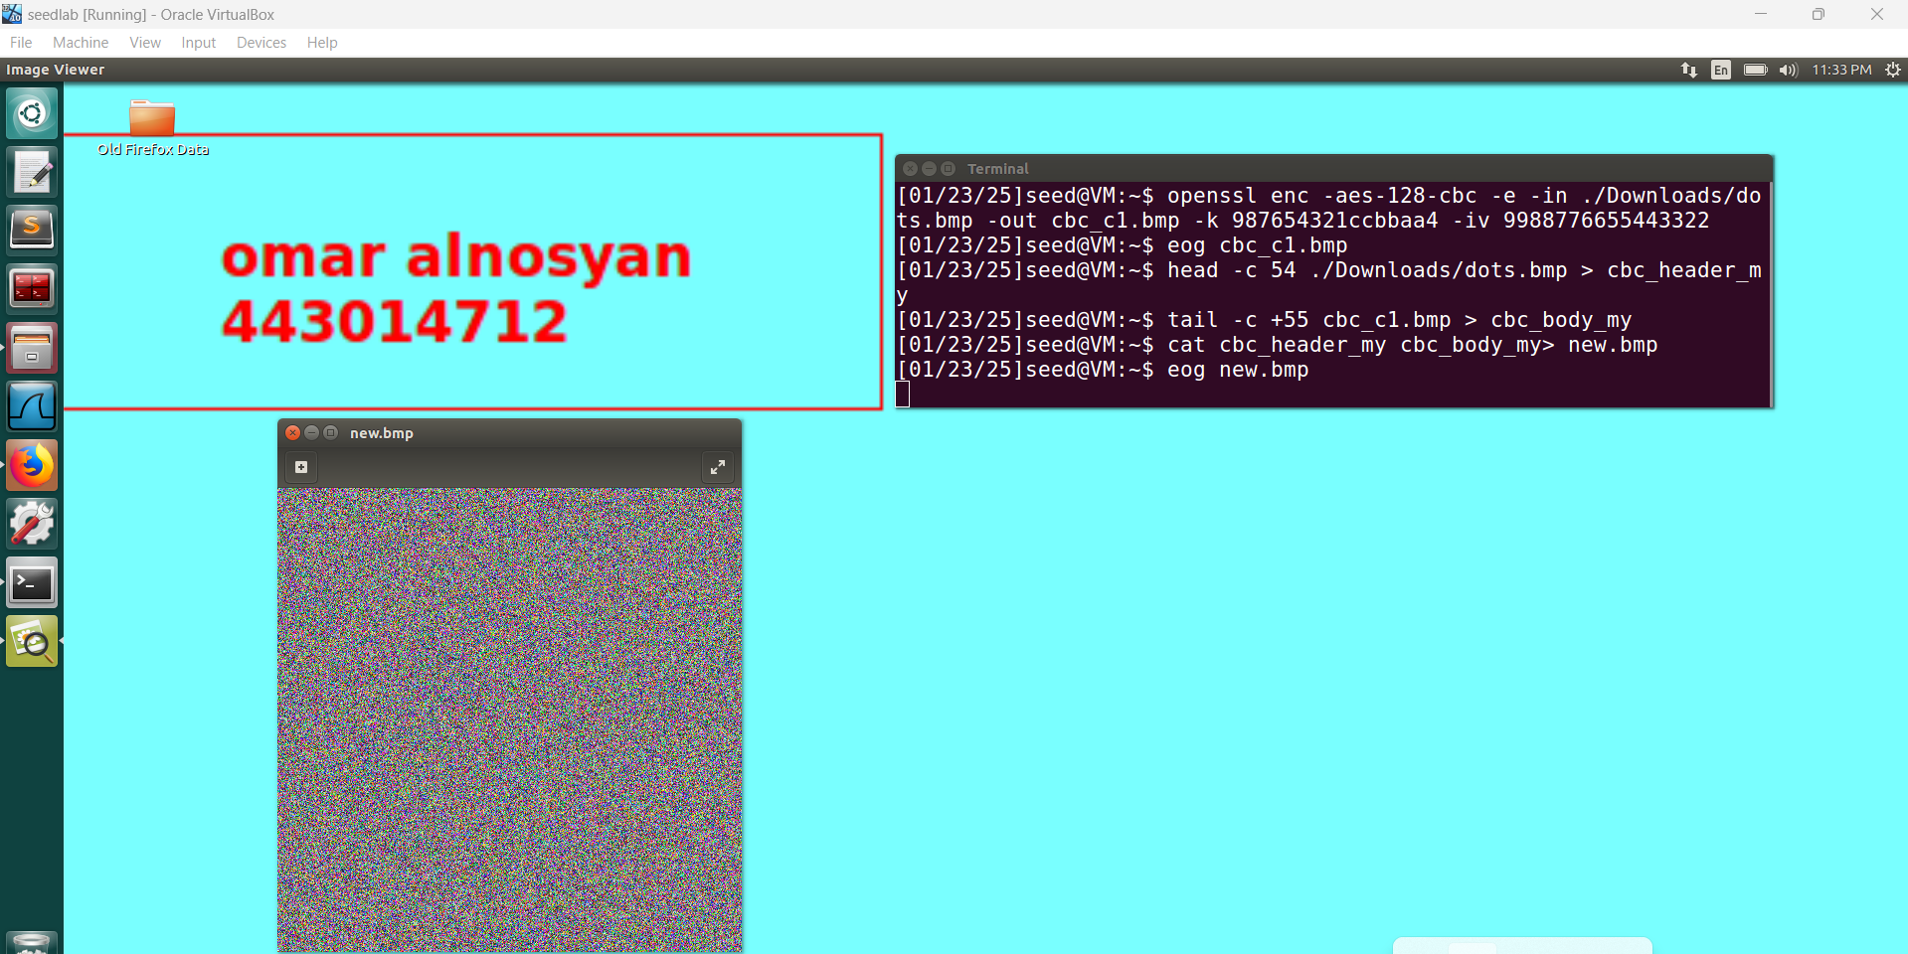

2- USING ECB MODE  **cipher**

**2- WE SHOW THE IMAGE BY USING EOG COMMAND**

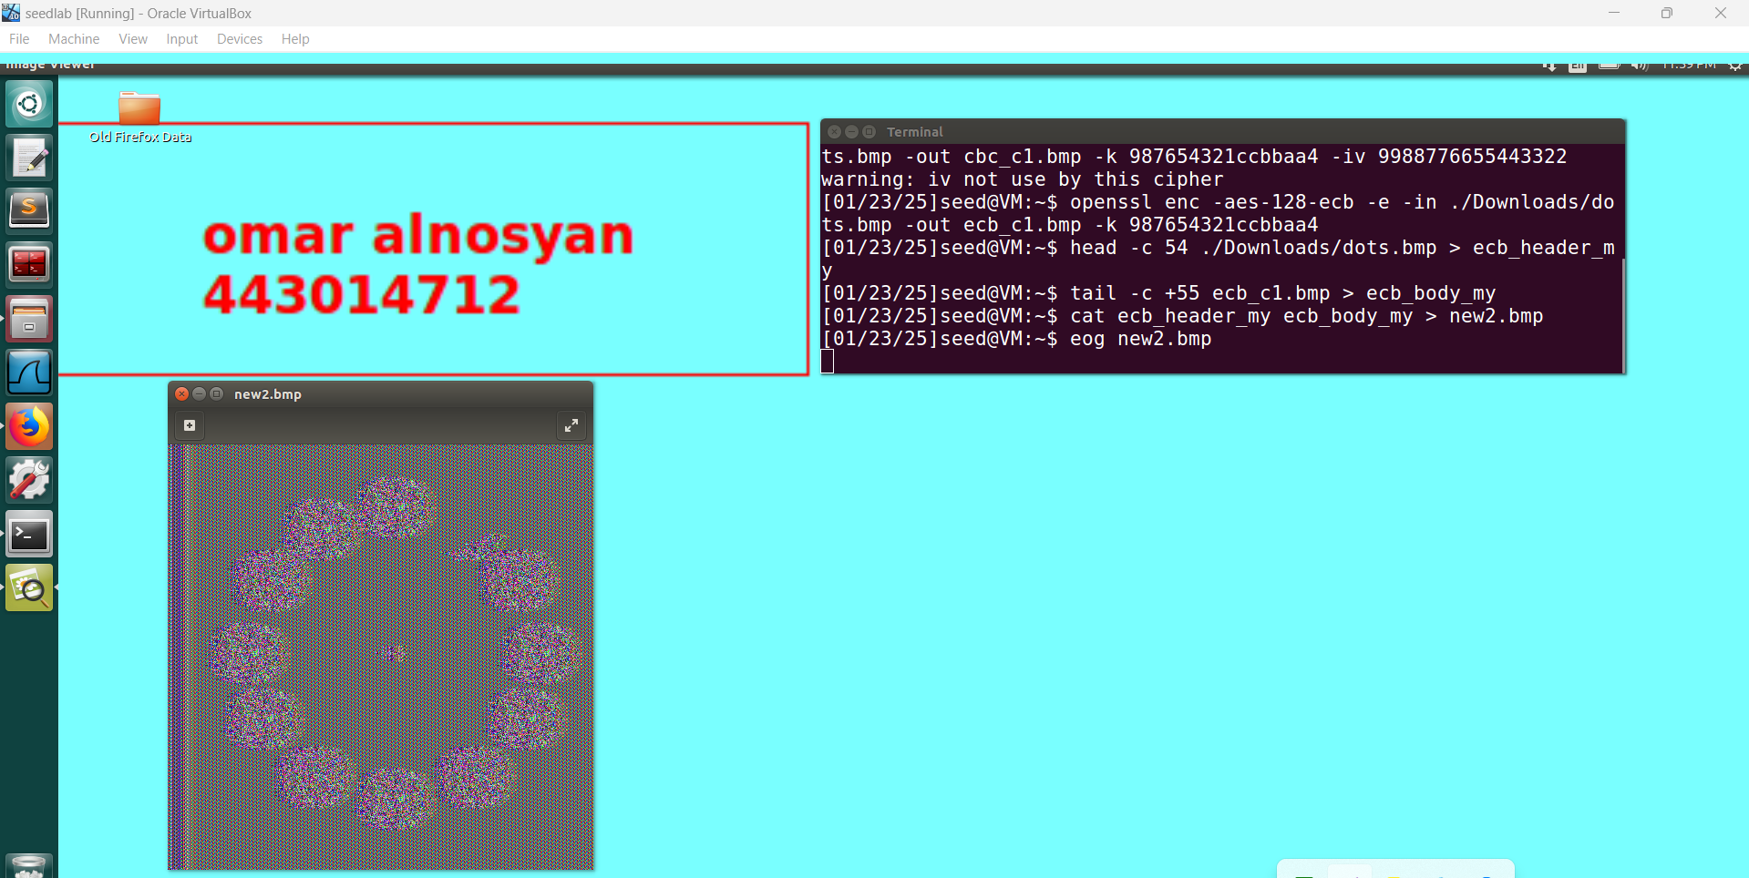

**Observation:**

By copying the first 54 bytes (the BMP header) from the original file into the encrypted file, we can open the new image in a viewer. However, because ECB encrypts identical plaintext blocks into identical ciphertext, much of the original image is still recognizable in the resulting BMP. Despite some distortion, most of the original image’s details remain visible  
  
  
  
**Task 7: Programming Using the Crypto Library in Java**

In Task 7, I’m given both a plaintext and a ciphertext, and my job is to figure out which AES-128-CBC key was used to encrypt the plaintext. I know the key is a single English word that’s shorter than 16 characters, and because AES-128 keys must be 16 bytes, the remaining bytes are filled with “#” (hex 0x23). Essentially, I’ll brute force all possible words from a dictionary by appending “#” until each candidate word becomes 16 bytes, then see if using that key to decrypt the given ciphertext actually yields the known plaintext. Once I find the match, that’s the key. It’s a fun exercise in dictionary attacks and seeing how padding works for AES keys.

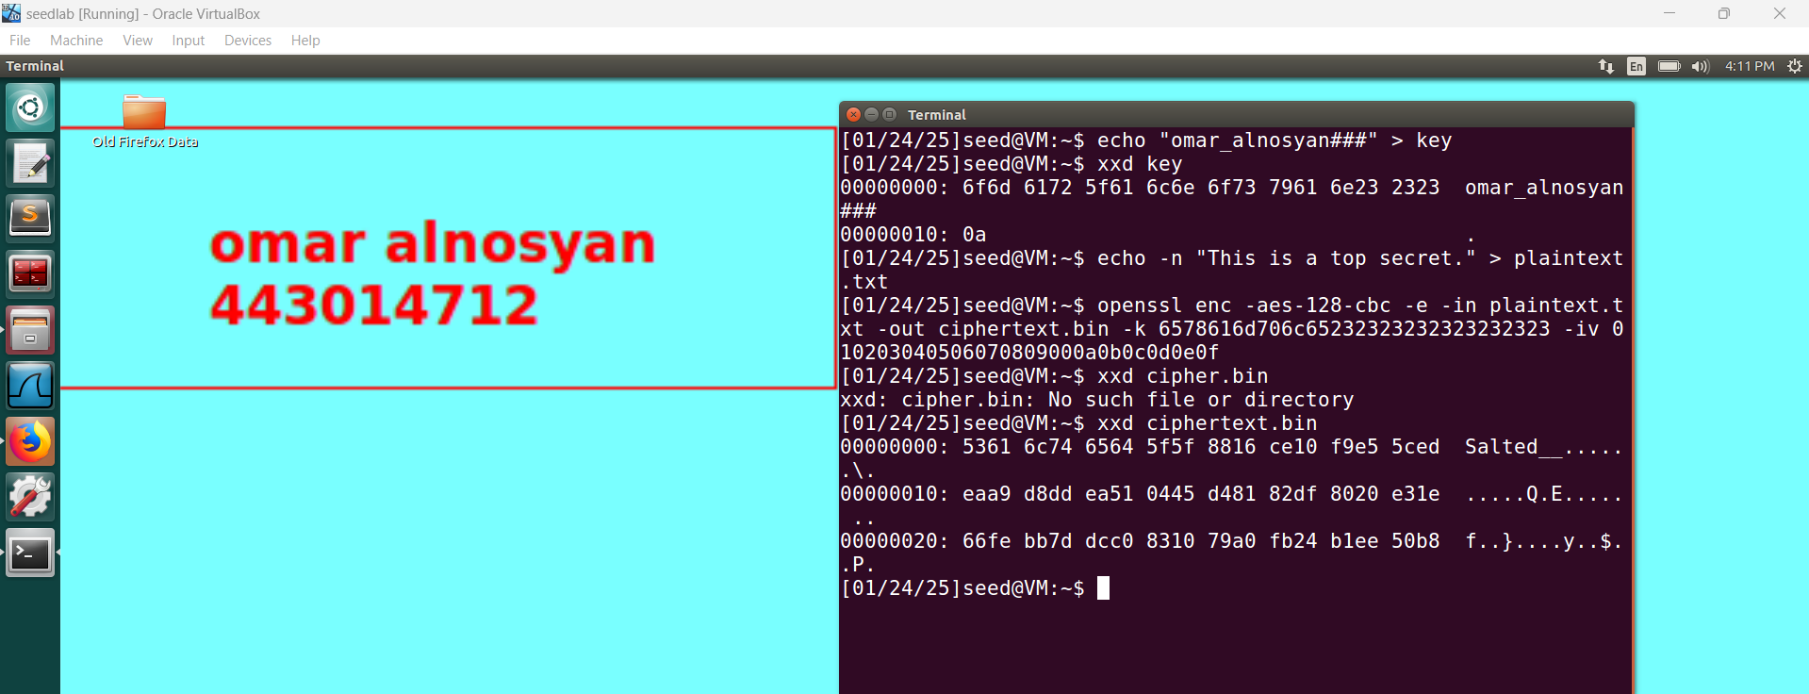

**Using AES-128-CBC:**

**Plain Tex = This is a top secret.**

**Key = from dictionary ⇒ Syracuse######## ⇒ 53797261637573652323232323232323 (in hex) ⇒ 16-byte (128-bit)**

**IV = aabbccddeeff00998877665544332211 (128-bit)**

**Ciphertext = 32 byte =**

**764AA26B55A4DA654DF6B19E4BCE00F4ED05E09346FB0E762583CB7DA2AC93A2**

**Step 1: Download and Install Java Environment**

**sudo apt-get install openjdk-8-jdk**

**Step 2: Set Up the Environment**

* **Navigated to the appropriate project directory in the Linux virtual machine:**

**cd /home/seed/Desktop/PROJECT/**

**Step 3: Compile and Run the Java Program**

* **Compiled the Java file using:**

**bash**

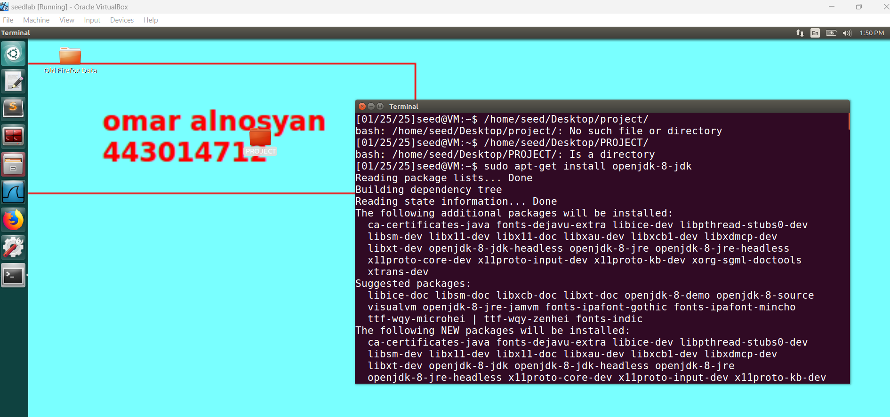

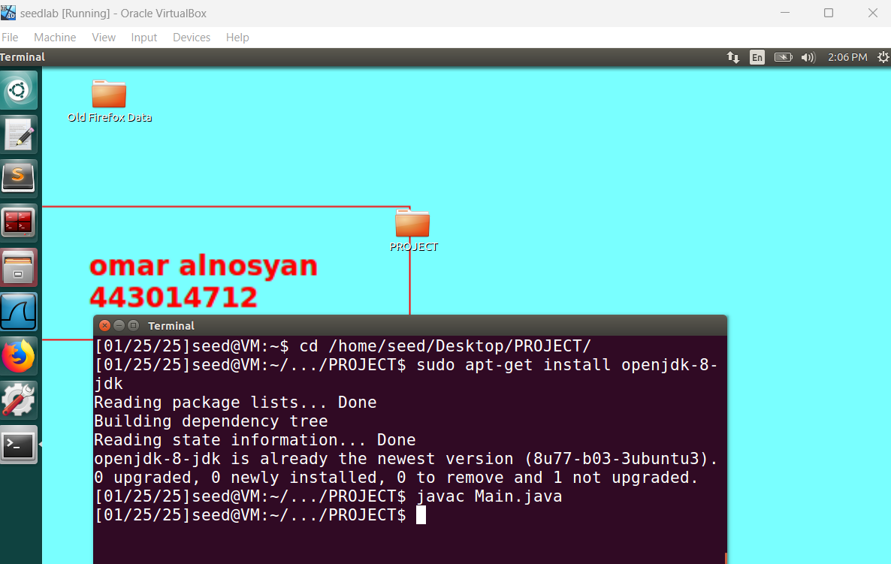

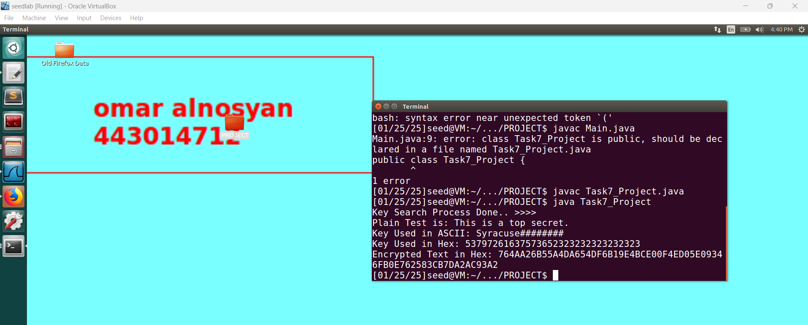

**1. Introduction**

**The purpose of this lab is to explore encryption and decryption using the Java Cryptography Architecture (JCA). We aim to understand how AES-128-CBC encryption works by implementing it to encrypt and decrypt sensitive data**

**2. Implementation Details**

* **Tools Used:**
  + **Java Development Kit (JDK 8 or later).**
  + **Text editor or IDE (e.g., Eclipse, IntelliJ, or VS Code).**
  + **Linux terminal for running the code.**
* **Steps:**
  + **Explain how the AES-128-CBC encryption is implemented.**
  + **Include key details:**
    1. **Loading the dictionary file containing potential keys.**
    2. **Padding keys to meet the AES key length requirement (16 bytes).**
    3. **Encrypting plaintext and matching it against a known ciphertext.**
    4. **Decrypting the ciphertext after identifying the correct key.**
  + **Provide key parts of the Java code, such as:**
    1. **Key padding logic.**
    2. **AES encryption and decryption methods.**
* **3. Code Example**
* **public static byte[] encrypt(String plaintext, byte[] initVector, String key) {**
* **try {**
* **IvParameterSpec iv = new IvParameterSpec(initVector);**
* **SecretKeySpec skeySpec = new SecretKeySpec(key.getBytes(), "AES");**
* **Cipher cipher = Cipher.getInstance("AES/CBC/PKCS5Padding");**
* **cipher.init(Cipher.ENCRYPT_MODE, skeySpec, iv);**



* **return cipher.doFinal(plaintext.getBytes());**
* **} catch (Exception ex) {**
* **return null;**
* **}**
* **}**

**Example Output:**

**Key Search Process Done... >>>>**

**Plain Text is: This is a top secret.**

**Key Used in ASCII: Syracuse#######**

**Key Used in Hex: 537972616375736520232323232323**

**Encrypted Text in Hex: 764aa26b55a4da654df6b19e4bce00f4ed05e09346fb0e762583cb7da2ac93a2**

**5. Conclusion**

Summary: In this lab, we successfully implemented AES-128-CBC encryption and decryption using the Java Cryptography Architecture (JCA). By using a dictionary file containing potential keys, we matched the correct key to decrypt the ciphertext. The program demonstrated how cryptographic functions work in practice and reinforced the importance of key management in secure communications.

Challenges:

* The primary challenge was handling file paths for the dictionary file (10th.txt). Using getResourceAsStream required placing the file in the correct location relative to the classpath.
* Another issue was managing exceptions during encryption and decryption processes, which required careful handling of invalid keys and padding.

Key Learnings:

* The significance of padding keys to meet the AES key length requirement (16 bytes).
* How to use Java's cryptographic libraries (Cipher, IvParameterSpec, and SecretKeySpec) for secure encryption and decryption.
* Practical understanding of matching ciphertext with encrypted text to verify the correct key.
* The importance of securely managing keys to prevent unauthorized access.

**6. References**

* **SEED Labs Documentation: Detailed explanation and guidelines on implementing cryptographic libraries in Java.**

**https://seedsecuritylabs.org/**

* **Java Cryptography Documentation: Official documentation of Java Cryptography Architecture (JCA) and its APIs.**
* **https://docs.oracle.com/javase/8/docs/technotes/guides/security/crypto/CryptoSpec.html**
* **Other Tools and Sources:**
  + **VirtualBox for running the SEEDLab environment.**
  + **Linux terminal commands for compiling and running Java programs.**
  + **Online Java resources and tutorials for understanding cryptographic APIs.**

